SRC Fall Half Full Marathon Training 2019

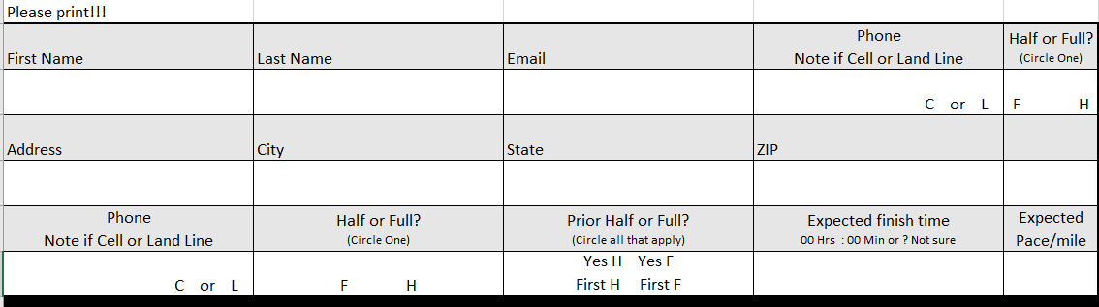
SRC Sponsored Event Waiver
I agree that I am participating in a walking/running event with the Scores Running Club (SRC) that are potentially hazardous activities, which could cause injury or death. I will not participate unless I am medically able and properly trained, and by my signature, I certify that I am medically able and properly trained. I agree to abide by all rules established by the club, including the right of any club official to deny or suspend my participation for any reason whatsoever. I attest that I have read these rules of the club and agree to abide by them. I assume all risks associated participating in this club event, which may include falls, contact with other participants, the effects of weather, including high heat and/or humidity, traffic and the conditions of the road, track or trails, all such risks being known and appreciated by me. I understand that bicycles, roller skates or in-line skates, and animals and personal music players are not allowed to be used in organized activities, and I agree to abide by this rule. I agree to wear and/or carry proper lighting and reflective gear when participating in any runs that warrant their use.
Having read this waiver and knowing the facts, and in consideration of your accepting my waiver, I, for myself and anyone entitled to act on my behalf, waive and release the Scores Running Club (SCR) of Keene, NH, the City of Keene, NH, and the Road Runners Club of America, all club sponsors, their representatives and successors from all claims or liabilities of any kind arising out of my participation with the club, even though that liability may arise out of negligence or carelessness on the part of the persons named in this waiver. I grant permission to all of the foregoing to use my photographs, motion pictures, recordings or any other record for any legitimate promotional uses for the club.

Signature: _______________________________ Parent’s Signature if under 18 years: __________________
Date: ___________ Date: _____________

