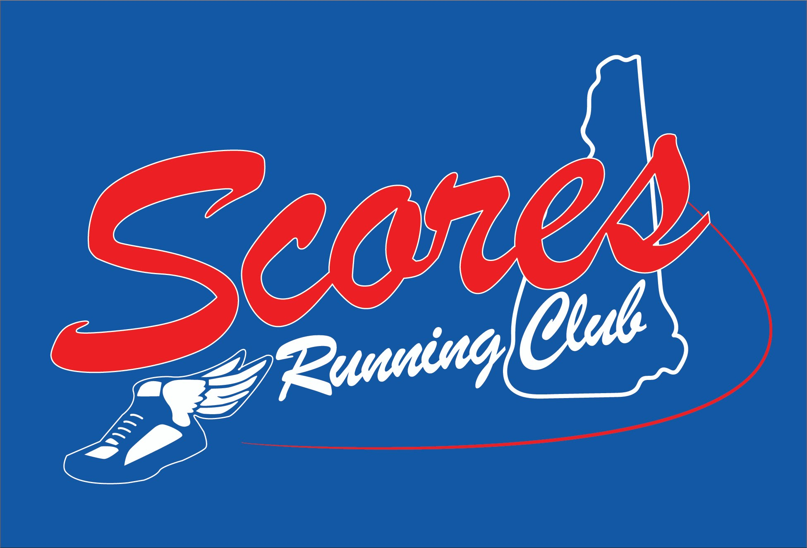

It’s the most wonderful time of the year – training season! It’s that time of the year where the runs mean a little more than knocking off the winter rust or just keeping a new year’s resolution. It’s time to get a plan and lace them up!

It you are planning a fall full or half marathon, either your first, fifth or fiftieth, why not run with a great support team to keep you on plan and motivated to cross that fall finish line. The members and friends of Scores Running Club are ready to be the team you need to meet your goals.

Join us on **Tuesday, June 25, 2019 at 5:30 PM** **@ Railroad Square** for a 3 mile fun run followed by a post run **informational meeting at 6:15 PM**. We will be discussing how you can meet your goal to complete the **Demar Marathon or Half Marathon, Sunday September 28, 2019.**

Scores Running Club a social running group and we support the idea that no one should run alone - running should be enjoyed with others to share the running experience. By training with other runners, you will have the opportunity to learn from experienced runners about their individual journeys to successful lifelong running; offering information about pace, hydration and nutrition, complimentary non-running exercises, and core strength and stretching that has made them successful, (and mostly) injury free runners.

Important information about the **Scores Running Club, Marathon or Half Marathon Training:**

* There is no cost to participate with this group. Running is a free sport!
* There is no expectation to join any running club. All are welcome!
* Interested first time half/ marathoners, should be able to run 3 consecutive miles prior to starting a training plan – at any pace.
* Group runs with pre-determined routes will be offered on Tuesdays, Thursdays and Sundays:
  + **Tuesdays - Railroad Square at 5:30 PM** - Post run social time at a downtown restaurant/bar after the run
  + **Thursdays - Ted’s Shoe and Sport at 5:30 PM** – Brief post run recap at Ted’s
  + **Sundays - Brewbaker’s Café at 7:30 am** - Post run social time at Brewbaker’s after the run

The 12 week plan starts with Week 1, Tuesday July 9:

Here is a proven training plan from the Runner’s World

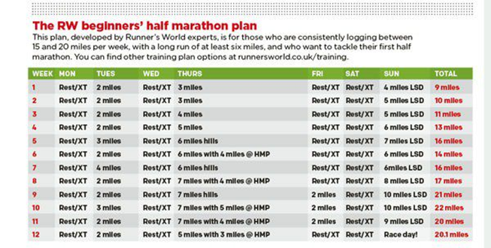

<https://www.runnersworld.com/uk/training/half-marathon/a25887045/beginner-half-marathon-training-schedule/>

Tips from RW:

1. **Go slowly** - You want to do nearly all your runs at a comfortable, conversational pace, and finish each run feeling like you have the energy – and desire – to run another mile. The biggest mistake first-timers make is running too many miles, too fast, too soon – and that’s a recipe for injury, loss of motivation and burnout. If at the end of your run, you’re gasping for air, or in pain, then you’re going too fast.
2. **Hit the hills -** Hillwork builds leg and lung power. Start by [incorporating hills](https://www.runnersworld.com/uk/training/motivation/10-best-hill-training-workouts) that take 60 seconds to climb. As you train and those 60-second hills become easier, challenge yourself with steeper and/or longer hills.
3. **Listen to your body-** A little muscle soreness comes with pushing your body further or faster, particularly in the calves, quads and hamstrings. Expect to take two days to recover from hard workouts. If you’re sore on the third day, rest again. Soreness beyond four or five days should get checked out by a doctor.
4. **Plan early for race day -** It’s not unusual to be worried. You can quiet the butterflies in your stomach by focusing on race-day logistics: carefully following both your nutrition and hydration plans, making it on time and properly equipped to the starting area, and meeting up with friends. When the gun goes off, control the urge to run fast right off and start comparatively slowly, aiming for a negative split – running the first half slower than the second. This conservative pacing will allow you to finish feeling in control.